**3134 Data Structures Homework 6 Written Solutions**

1.(10 pts): Weiss, Exercise 9.15

Kruskal's Algorithm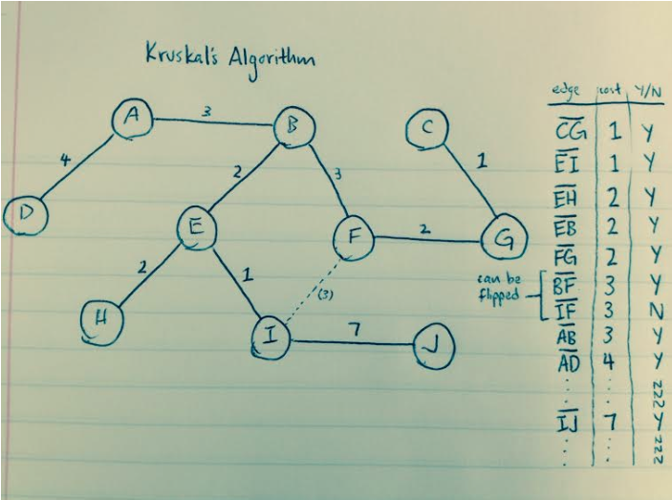

edge cost Y/N

CG 1 Y

EI 1 Y

EH 2 Y

EB 2 Y

FG 2 Y

BF|IF 3 Y*can be one or the other

AB 3 Y

AD 4 Y

. N

. N

. N

IJ 7 Y

. N

. N

. N

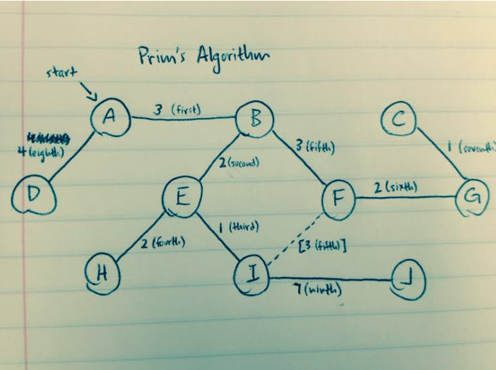

Prim's Algorithm

edge cost order

AB 3 1

BE 2 2

EI 1 3

EH 2 4

BF|IF 3 5

FG 2 6

GC 1 7

AD 4 8

IJ 7 9

'

**Prim's, Book Version:**

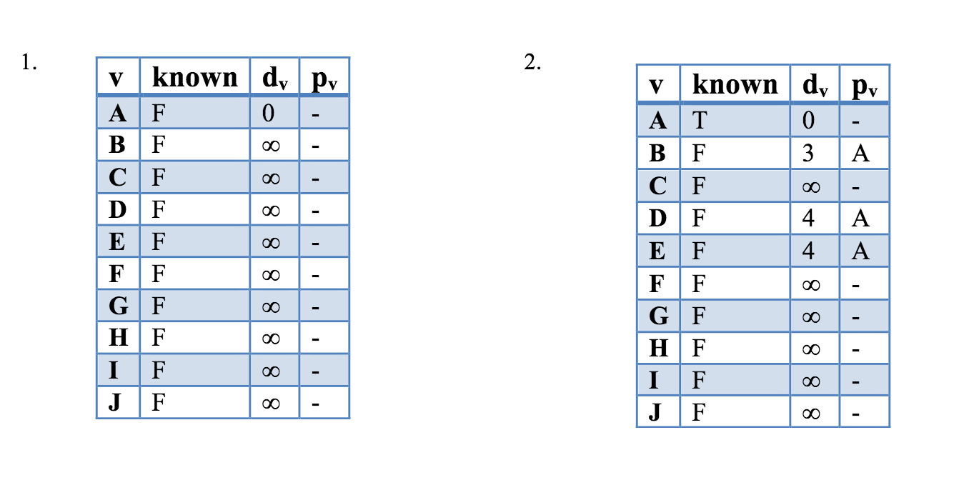

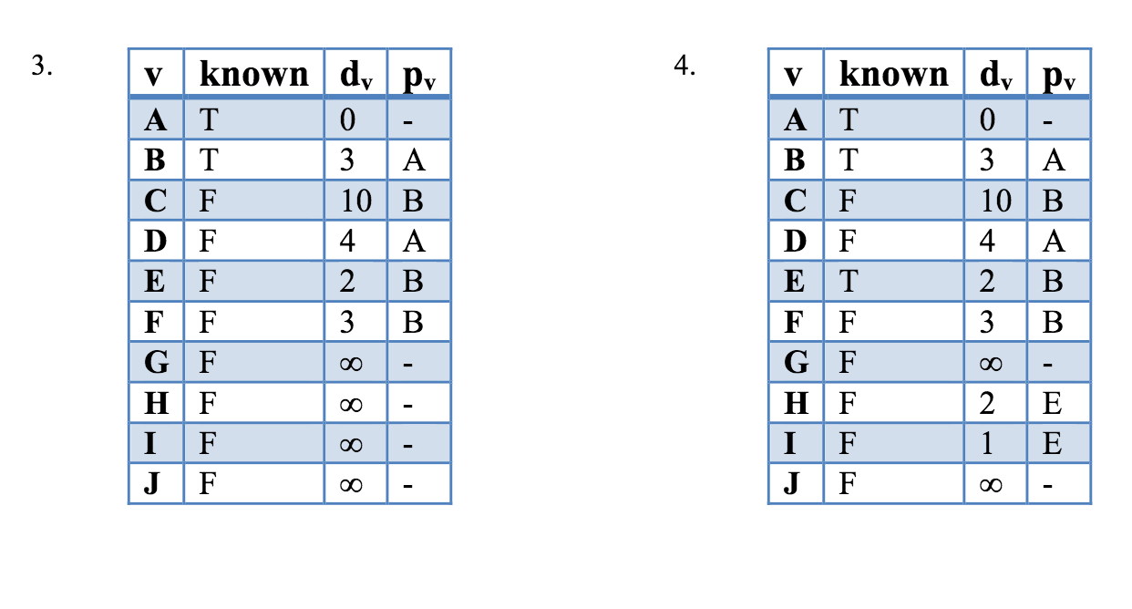

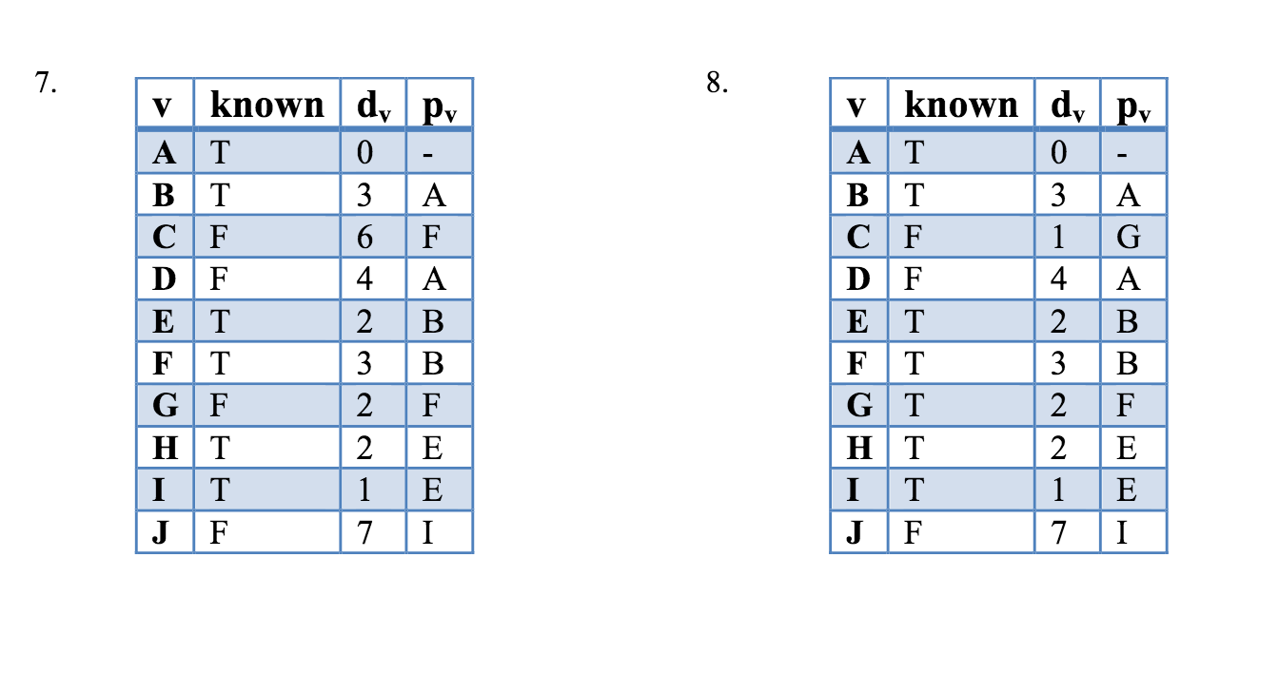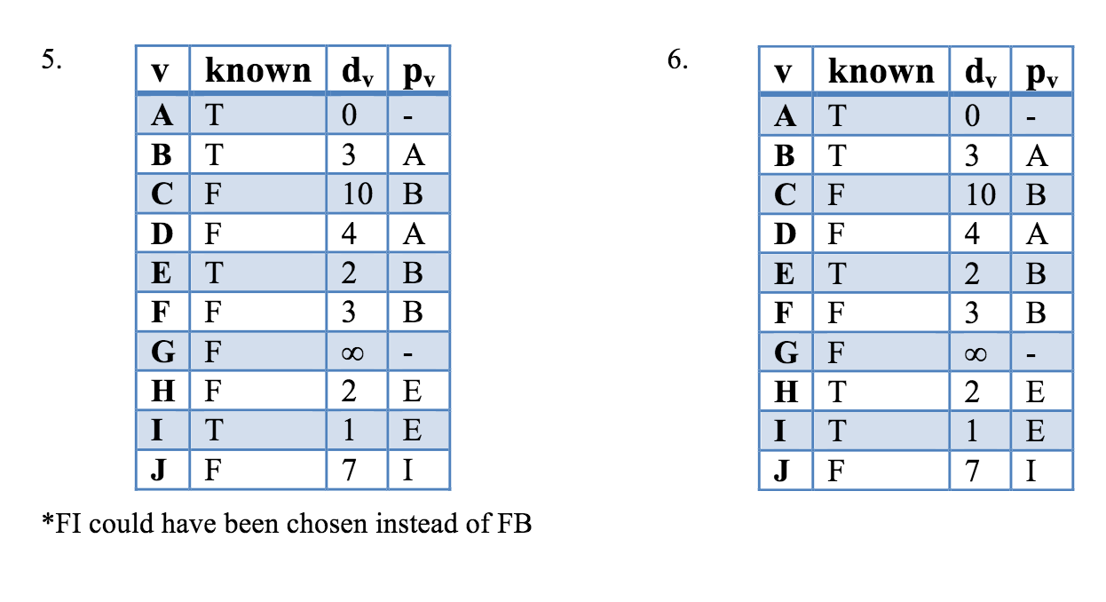

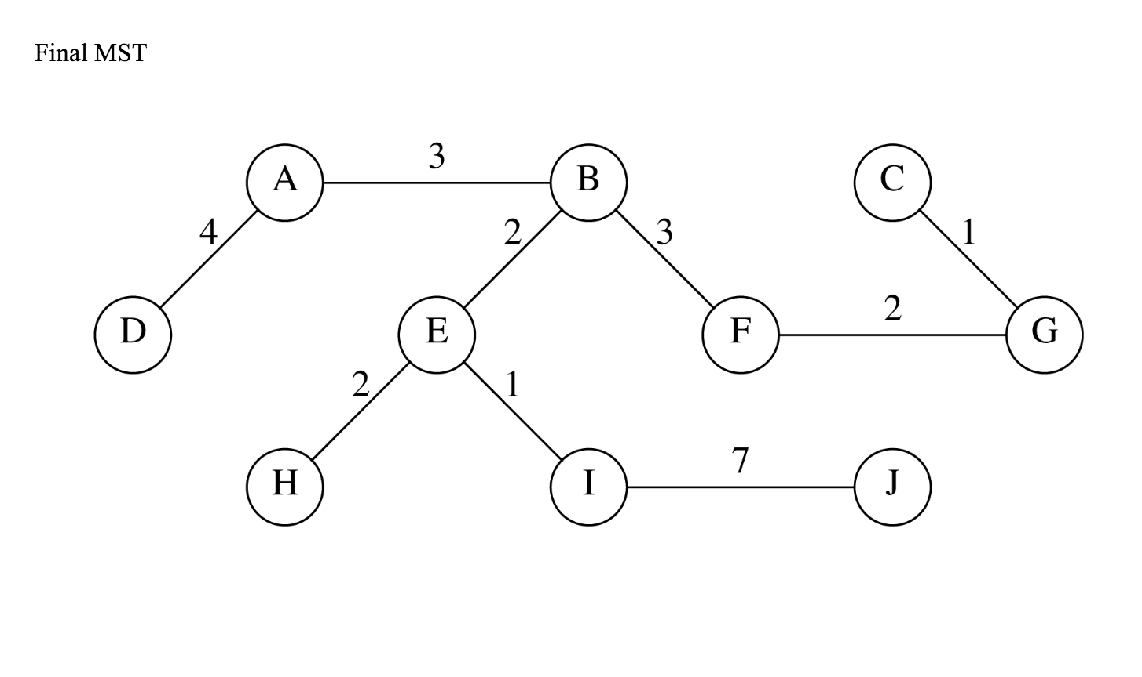

**Prim's, Class Version**

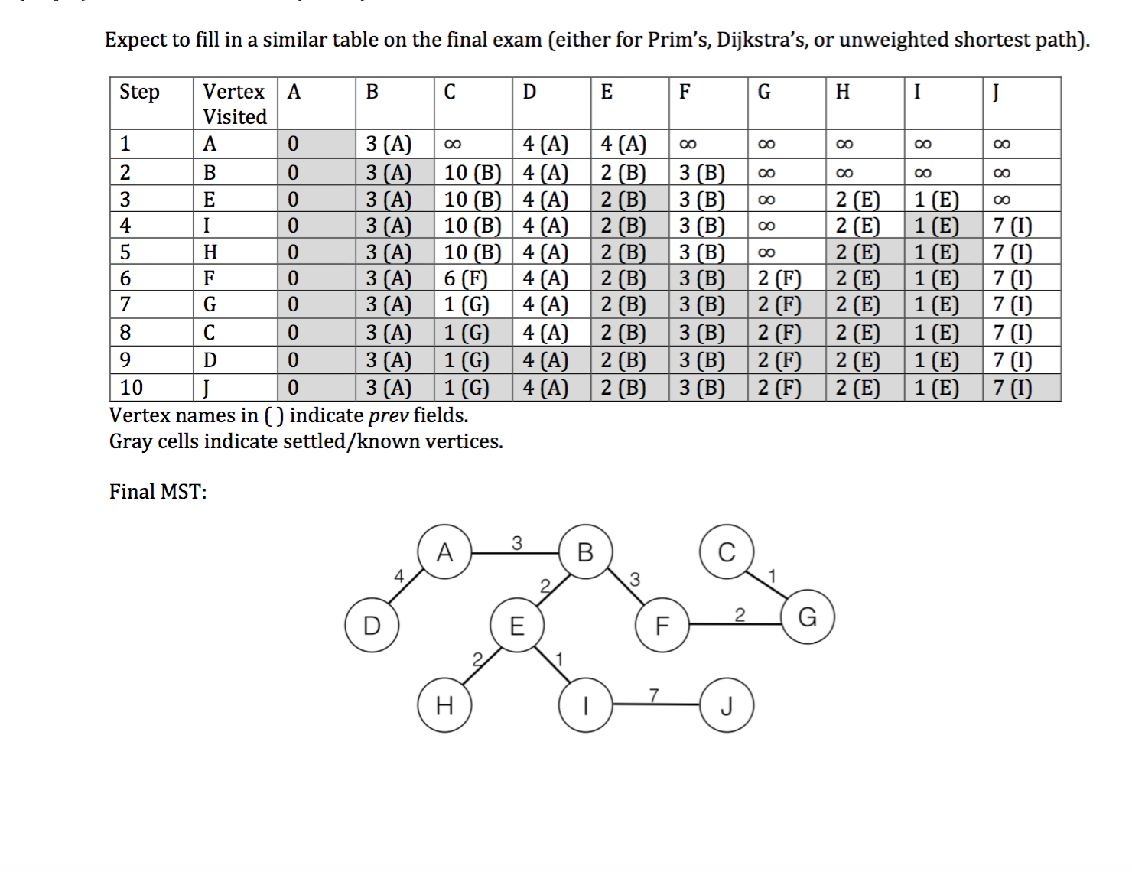

2.(10 pts): Weiss, Exercise 9.53 (From book solutions)

A: Each actor is a vertex; an edge connects two vertices if the actors have starred in the same movie. To find the Bacon number, simply find the shortest path between the given actor (source) and Kevin Bacon (target) using any of the algorithms covered in class.

B: Starting with Kevin Bacon, find all “paths” using DFS or another similar algorithm. Pick the longest path from the set of paths.

C: Similar to A, find minimal number of links between any two actors by setting one actor as source, another as target, and running any of the shortest-path algorithms.